Cognitive Foraging and the Wayfinder Controller: An Architectural Blueprint for Multi-Scale Adaptive Instructional Systems
Designing a next-generation adaptive learning engine requires moving beyond the conventional "curriculum with a difficulty dial" to model the learner as a cognitive forager navigating a dynamic knowledge landscape under a multi-timescale controller called Wayfinder¹. Historically, adaptive instructional technologies evolved along four largely separate tracks: psychometric item selection via Computerized Adaptive Testing (CAT) and Item Response Theory (IRT)⁵, step-level cognitive diagnosis in Intelligent Tutoring Systems (ITS) via Bayesian Knowledge Tracing (BKT) and Performance Factors Analysis (PFA)⁷, combinatorial prerequisite mapping via Knowledge Space Theory (KST)⁹, and memory scheduling via spaced repetition queues⁵. While each lineage solves a localized estimation problem, production engines almost universally collapse instructional policy into a single myopic rule: picking the next item to target a fixed probability of correctness, such as the 85% accuracy sweet spot derived for gradient-descent binary classifiers¹². Consequently, existing systems answer only what a learner is ready to attempt next⁹. They lack a unified formal mechanism to decide when a skill patch has yielded diminishing returns, when a persistent error reflects a structured misconception rather than random noise, when to shift the learner's cognitive role, or whether apparent mastery transfers to novel contexts¹⁴.
Cognitive Foraging and the Wayfinder controller unify these disconnected mechanisms by synthesizing principles from optimal foraging ecology¹, partially observable optimal control³, Bayesian experimental design²⁰, statistical physics²², immunology¹⁵, cognitive apprenticeship¹⁶, and real options economics⁴. Instead of maximizing immediate item correctness, Wayfinder maintains a multi-dimensional distributional learner model and plans short trajectories across four nested timescales (Micro, Meso, Macro, and Meta) to maximize Expected Transferable Learning per Unit of Attention (ETL/UA) subject to lexicographic safety, due-review, and prerequisite readiness constraints⁴. Within this framework, spaced repetition is no longer an external scheduler fighting the mastery model; it is modeled organically as ecological patch regeneration¹. Similarly, scalar difficulty sliders are replaced by a Productive Surprise diagnostic regime that uses response accuracy, metacognitive confidence, and latency together to distinguish cognitive overload from high-confidence misconceptions⁴.
In Monte Carlo simulation benchmarks across five synthetic learner archetypes—calibrated learners, overconfident misconception-prone learners, wheel-spinners, underconfident hint-abusers, and rapid forgetters—a deterministic 3-step lookahead Wayfinder controller (Wayfinder_MPC_3Step) outperforms classical BKT with SuperMemo-2 scheduling (BKT_Threshold_SM2) and scalar 85%-accuracy IRT controllers (IRT_85_Rule) by 2.56x on 14-day delayed mastery (0.4174 vs. 0.1628) and by 7.81x on novel-context transfer (0.3826 vs. 0.0490), while reducing unproductive wheel-spinning from 90.00% of instructional steps to 17.04%⁴. Crucially, this architecture does not require opaque deep reinforcement learning or neural knowledge tracing to launch; its first-generation implementation (Wayfinder v1) is deterministic, auditable, and explainable, confining Large Language Models (LLMs) strictly to accountable content and hint generation while retaining policy authority inside the controller⁴.

1. Taxonomy of the Adaptive Landscape & Architecture Synthesis
The nomenclature of adaptive education reflects distinct research, standards, and commercial communities, each contributing a partial module to the end-to-end instructional pipeline. Mapping how these lineages connect—from item calibration through to path selection—clarifies why conventional architectures suffer from policy drift and how Cognitive Foraging unifies them.

1.1 Nomenclature across Research, Standards, and Industry Lineages
Across academic conferences (AI in Education [AIED], Educational Data Mining [EDM], Learning Analytics and Knowledge [LAK]), standards bodies (IEEE Learning Engineering), and commercial product ecosystems, terminology divides according to whether the system adapts macro-pathways, micro-step hints, psychometric item selection, or conversational dialogue:

Lineage / Category | Core Term | Primary Mechanism & Theoretical Lineage | Canonical Systems & Examples | Architectural Limitation Addressed by Wayfinder
Umbrella & Standards | Adaptive Learning | Broad adjustment of content, sequence, pacing, or difficulty based on learner performance telemetry²⁶. | Commercial edtech & LMS platforms | Conflates static branching rules with dynamic closed-loop control.
Umbrella & Standards | Adaptive Instructional Systems (AIS) | Formal architecture standards separating domain, learner, and pedagogical models (IEEE / Learning Engineering). | GIFT, IEEE AIS standards | Defines modular interfaces but leaves cross-timescale conflict resolution unspecified.
Umbrella & Standards | Intelligent Tutoring Systems (ITS) | One-to-one tutoring behavior via step-level diagnosis, model tracing, hints, and immediate feedback over production rules². | Carnegie Learning Cognitive Tutor, ASSISTments, Andes Physics⁷ | Excels at micro-step scaffolding but can trap learners in local "wheel-spinning" loops¹⁴.
Umbrella & Standards | Personalized Learning | Marketing and L&D umbrella combining algorithmic routing with learner choice or self-paced pathways. | Corporate L&D, Learning Experience Platforms (LXPs) | Often treats learner overrides as noise or surrenders pedagogical rigor to uncalibrated preferences.
Item & State Estimation | Computerized Adaptive Testing (CAT) | Selects the next question based on estimated ability using Item Response Theory (IRT) to maximize measurement information⁵. | GRE, GMAT, Amsterdam Chess Test⁶ | Optimizes measurement precision of a static trait rather than longitudinal learning gain⁶.
Item & State Estimation | Knowledge Tracing (KT) | Longitudinal estimation of latent skill mastery over time from sequential binary responses⁸. | BKT⁸, PFA⁸, Deep Knowledge Tracing (DKT)²⁵ | Point-estimate mastery ignores epistemic uncertainty, active misconceptions, and context transfer⁴.
Item & State Estimation | Learner / Student Modelling | Broader maintenance of a representation of what a learner knows, believes, or misunderstands⁷. | BUGGY¹⁷, Help Tutor²⁷, SMILI☺ Open Learner Models³² | Rarely coupled directly to a single multi-objective trajectory planner³.
Routing & Pedagogy | Knowledge Space Theory (KST) | Combinatorial mapping of feasible knowledge states via surmise (prerequisite) relations and inner/outer fringes⁹. | ALEKS (Assessment and Learning in Knowledge Spaces)⁹ | Identifies what a student is ready to learn (outer fringe), but not when to abandon a depleted patch⁹.
Routing & Pedagogy | Mastery Learning & Curriculum Sequencing | Gating progression on reaching a fixed mastery threshold (e.g., 0.88–0.95) along a directed graph⁴. | Khan Academy Mastery, Knewton, Smart Sparrow, Realizeit, Cogbooks, Duolingo³⁷ | Fixed thresholds ignore marginal learning rates and fight separate spaced-repetition schedulers⁴.
Routing & Pedagogy | Zone of Proximal Development (ZPD) | Vygotskian targeting of items just beyond current independent ability via contingent scaffolding¹⁶. | ZPDES Bandit Tutors³⁸, Cognitive Apprenticeship¹⁶ | Often reduced in software to a scalar difficulty slider rather than multidimensional role/scaffold shifting²⁴.
Generative AI | Generative / Conversational Tutoring | LLM-based adaptive tutoring where adaptation emerges from dialogue rather than a pre-built item bank and path graph³⁵. | LLM-based AI tutors, conversational courseware | High policy drift and sycophancy risk when LLMs are granted path-selection authority.

1.2 How the Pieces Fit Together: From Item Calibration to Path Selection
In a conventional adaptive architecture, data flows through five sequential stages developed by overlapping research communities in EDM, LAK, AIED, and applied Learning Engineering⁸:
- Domain Cartography & Prerequisite Extraction: Authors or automated algorithms—such as the expert-querying QUERY algorithm in Knowledge Space Theory (Koppen & Doignon, 1990) or Learning Factors Analysis (LFA; Cen, Koedinger, & Junker)—decompose a subject domain into atomic Knowledge Components (KCs) or problem types⁸. Prerequisite partial orders (surmise relations) define the Directed Acyclic Graph (DAG) of feasible knowledge states, where a learner's inner fringe represents what they have most recently mastered and their outer fringe represents the exact items they are ready to learn next⁹.
- Psychometric Item Calibration: Historical response logs are fit using Rasch (1PL), 2PL, or 3PL Item Response Theory models to estimate item difficulty (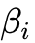 or ), discrimination, and careless slip (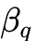) or lucky guess (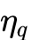) parameters⁴³, or multi-KC Q-matrices in LFA and Performance Factors Analysis⁸.
- Knowledge Tracing & State Updating: As a learner interacts with calibrated items, the student model updates its latent state estimate. Classical Bayesian Knowledge Tracing (BKT; Corbett & Anderson, 1994) maintains a two-state Hidden Markov Model per skill governed by four parameters—initial learning probability (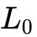), transition/learning probability (), guess (), and slip ()⁸. Performance Factors Analysis (PFA; Pavlik, Cen, & Koedinger, 2009) reconfigures logistic regression to predict the log-odds of correctness 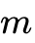 from item/KC difficulty plus scaled counts of prior successes (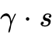) and failures (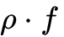) across multiple KCs, avoiding BKT's overly aggressive downward adjustment after a single error⁸. Deep Knowledge Tracing (DKT) replaces explicit Markov states with recurrent neural networks, though systematic audits by Khajah, Lindsey, and Mozer (2016) demonstrate that DKT's predictive gains over standard BKT are largely matched when BKT is extended with forgetting decay, student ability priors, and skill discovery²⁵.
- Inner-Loop Micro-Adaptation: Within a multi-step problem, an ITS uses model tracing over ACT-R production rules (IF <condition> THEN <actions>) to compare student actions against expert problem-space paths, flagging procedural bugs and delivering graduated context-sensitive hints².
- Outer-Loop Path Selection & Review Scheduling: A macro-sequencer routes the learner to the next unmastered skill in the outer fringe once estimated mastery crosses a fixed threshold (e.g., 0.88–0.95)⁴, while an independent spaced repetition scheduler—such as a Leitner queue network (Reddy, Labutov, Banerjee, & Joachims, 2016)⁵ or a marked temporal point-process controller (MEMORIZE; Tabibian et al., 2019)¹¹—interrupts forward progress to schedule reviews as memory decays.
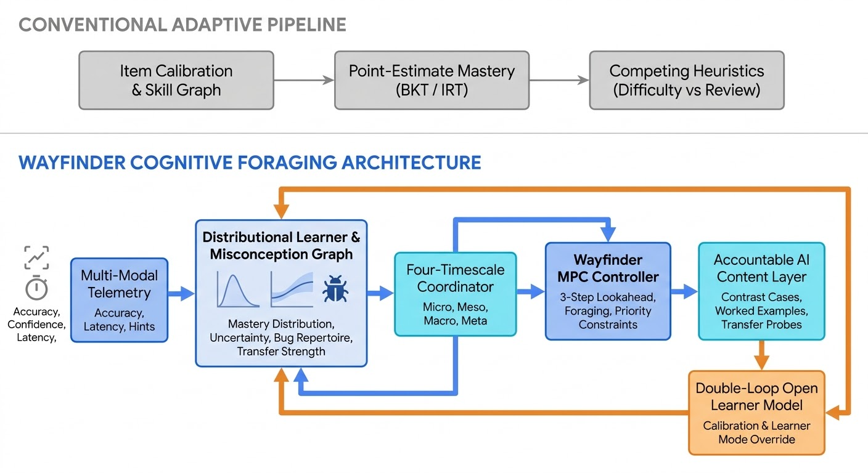

1.3 Why the "Curriculum with a Difficulty Dial" Fails
When these traditional modules are bolted together in production, three structural pathologies emerge. First, classical mastery-learning loops frequently trap learners in wheel-spinning—defined by Beck and Gong (2013) as situations in which learners persist for extended periods of time on a skill without achieving mastery or demonstrating durable learning¹⁴. Because a point-estimate BKT or IRT loop only registers low mastery, it continues serving standard items on the same skill rather than recognizing that the local patch is depleted or blocked by an unmeasured prerequisite gap or misconception⁴.
Second, clamping practice to a fixed scalar success rate—such as the Eighty-Five Percent Rule derived by Wilson, Shenhav, Straccia, and Cohen (2019)—misapplies a perceptual gradient-descent optimum to structured human cognition¹². Wilson et al. demonstrated theoretically and in neural network simulations that for stochastic gradient-descent algorithms in binary classification tasks under Gaussian noise, clamping training accuracy to around 85% (an optimal error rate of 15.87%) maximizes the rate at which representation precision improves¹². However, human conceptual learning is not homogeneous gradient descent over a stationary binary boundary⁴⁹. A learner who achieves 85% accuracy via slow, low-confidence guessing requires schema consolidation and self-explanation, whereas a learner who commits a fast, 90%-confident error is executing a systematic procedural bug¹⁷ that can be rapidly dismantled via the hypercorrection effect¹⁵. Reducing difficulty to a single scalar slider discards the diagnostic signal carried by response latency and metacognitive confidence⁶.
Third, when engineering teams patch these gaps by adding independent heuristics—a Leitner queue for spaced review⁵, an extrinsic gamification layer (streaks, badges, XP counters) for engagement⁵³, a threshold rule for prerequisites, and an error-count trigger for hints—the heuristics collide. Research syntheses on the 85% rule versus gamification highlight that visible point counters and streaks recruit an extrinsic reward circuit that displaces intrinsic motivation, shifts feedback from process-level to self-level, and amplifies anxiety for struggling learners⁵³. Meanwhile, the spaced-repetition scheduler pulls the learner away just as a conceptual breakthrough begins, causing the engine to oscillate silently between competing rules.

2. Theoretical Foundations of Cognitive Foraging: The Seven Borrowed Lenses
Cognitive Foraging reconceptualizes learning not as the accumulation of correct answers, but as an active search through a patchy knowledge landscape governed by resource depletion, regeneration, information value, and context transfer². This requires the engine to continuously answer three foundational questions:
- Readiness: What is the learner ready to learn? (The outer fringe of prerequisite readiness and epistemic uncertainty)⁹.
- Patch Productivity: Is this patch still productive, or should we move? (Marginal learning rate relative to switching costs and alternative patches)¹.
- Transferability: Will this help later, in a different context? (Retention stability, cross-skill transfer coupling, and downstream option value)⁴.
To answer all three questions within a single mathematical framework, Wayfinder synthesizes seven cross-disciplinary lenses:

2.1 Ecology: Optimal Foraging and the Marginal Value Theorem (MVT)
In behavioral ecology (Charnov, 1976; Eliassen et al., 2009) and Information Foraging Theory (Pirolli, 2007), an agent harvesting resources in a patchy environment faces a fundamental patch-departure decision¹. Within any skill patch , cumulative knowledge gain 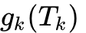 exhibits diminishing marginal returns as local attention time 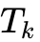 increases¹. Charnov's Marginal Value Theorem shows that the rate-maximizing time  to spend in a patch occurs when the instantaneous marginal rate of intake 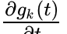 drops to the long-term average return rate across available patches, after accounting for the travel (switching) cost 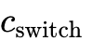 between patches¹:
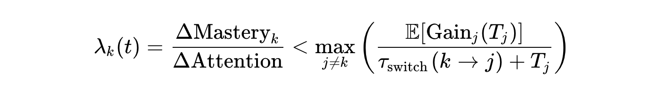
Because direct application of MVT assumes omniscience regarding patch quality, practical foraging controllers approximate MVT online using reinforcement-learning or moving-average estimates of patch gain rates and differential travel costs¹. Crucially, in Cognitive Foraging, spaced review is not a separate scheduler fighting the mastery model; it is patch regeneration¹. When a learner leaves a mastered patch, memory traces undergo temporal decay while consolidation progresses; over elapsed time, the potential marginal return of revisiting that patch to multiply memory stability 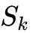 regenerates⁴. Wayfinder returns to a skill for review when its regenerated marginal return exceeds the yield of staying in the current patch.

2.2 Control Theory: Model Predictive Control (MPC) and POMDP Planning
Selecting a single next item myopically cannot capture multi-step pedagogical synergies—such as destabilizing a misconception with a contrasting case in step so that a guided worked example in step 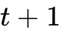 achieves a "time for telling" breakthrough⁴. Formulating instruction as a Partially Observable Markov Decision Process (POMDP), as demonstrated by Rafferty, Brunskill, Griffiths, and Shafto (2016), maps the learner's hidden knowledge state to a probabilistic belief state and selects pedagogical actions to optimize discounted future value over a planning horizon³. Because offline infinite-horizon POMDP solvers become computationally intractable as the state space scales across continuous multi-skill models³, Wayfinder implements receding-horizon Model Predictive Control (MPC): at each decision epoch, the controller forecasts belief trajectories over a short lookahead horizon (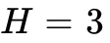 steps), scores the composite trajectory under system constraints, executes the first action 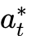, observes the learner's response, and replans⁴.

2.3 Information Theory: Bayesian Experimental Design (ADO)
Standard adaptive engines select items where the learner is likely to succeed, conflating assessment with reinforcement. Drawing on Adaptive Design Optimization (ADO; Myung, Cavagnaro, & Pitt, 2013), Wayfinder treats diagnostic probing as an optimal Bayesian experiment²⁰. In ADO, each candidate activity or stimulus design is evaluated by a utility function based on mutual information—equivalent to expected Shannon entropy reduction—between the latent learner parameters  (mastery 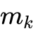 and misconception state 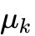) and the predicted observation ²¹:

As Myung et al. note, the observation that yields the highest expected information gain is the one whose outcome reduces posterior uncertainty in the fewest steps²¹. Thus, a skill at 70% estimated mastery with high epistemic variance (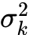) triggers a fast, low-scaffold diagnostic probe, whereas a skill at 70% mastery with tight posterior certainty receives targeted practice or transfer challenges⁴.

2.4 Statistical Physics: Criticality and Productive Surprise
Autonomous developmental systems, such as Oudeyer, Kaplan, and Hafner's (2007) Intelligent Adaptive Curiosity (IAC), demonstrate that intrinsic learning progress peaks neither in overly predictable regimes (where prediction error is zero and attention drops) nor in chaotic regimes (where excessive complexity overwhelms the learner's predictive model)²². Instead, developmental sequences self-organize at the edge of chaos—an intermediate zone of productive surprise where the expected reduction in prediction error is maximal²². Wayfinder operationalizes criticality not by clamping accuracy to 85%, but by targeting a band of prediction error indexed jointly by learner confidence, response accuracy, and speed-accuracy drift⁴.

2.5 Immunology: The Misconception Repertoire
In the diagnostic ITS lineage founded by Brown and Burton's (1978) BUGGY model, student errors in procedural skills are recognized not as random failures, but as symptoms of discrete "bugs"—systematic modifications to correct production rules (e.g., subtracting the smaller digit from the larger regardless of column position, or blindly accepting HEAD in a Git merge conflict)⁴. Cognitive Foraging treats misconceptions as recurring cognitive pathogens¹⁷. While Butterfield and Metcalfe (2001) showed that errors committed with high confidence are strongly hypercorrected upon immediate feedback¹⁵, longitudinal memory studies by Butler, Fazio, and Marsh revealed that if the corrective memory trace is forgotten over time, the original high-confidence error is likely to resurface⁶⁰. Wayfinder therefore maintains an explicit misconception repertoire for each learner, deploying side-by-side contrasting cases (cognitive antigens) followed by spaced immunization exposures to build durable resistance⁴.

2.6 Cognitive Apprenticeship: Dynamic Role Adaptation
Collins, Brown, and Newman (1989) established that formal schooling often fails because expert thinking processes remain invisible behind finished text or lectures¹⁶. Cognitive Apprenticeship makes tacit cognitive and metacognitive processes visible across six teaching methods: Modeling, Coaching, Scaffolding (with Fading), Articulation, Reflection, and Exploration¹⁶. However, systematic reviews of STEM implementations indicate that digital environments overwhelmingly implement only coaching and scaffolding (15.3% of applied codes across 17 studies) while neglecting reflection (3.5%), articulation (3.5%), exploration (2.9%), and sequencing (5.3%)⁶¹. Wayfinder embeds role progression directly into its action space, moving the learner from Observer (analyzing contrasting cases and expert think-aloud models) to Guided Practitioner (executing decisions with visible scaffolding) to Independent Practitioner & Reviewer (articulating explanations, auditing buggy examples, and solving far-transfer probes as support fades)⁴.

2.7 Economics: Real Option Value in Curriculum Graphs
In a structured knowledge space, foundational skills possess high option value (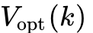): keeping a core prerequisite alive and fluent above its readiness threshold unlocks a wide fan of downstream outer-fringe paths and synthesis projects⁴. Wayfinder incorporates real option value into its objective scorer, justifying brief maintenance reviews on high-centrality skills before their decay locks out future curriculum trajectories⁴.

3. Formal Mathematical Specification of the Wayfinder Engine
To eliminate the policy drift caused by competing heuristics, Wayfinder enforces a single architectural invariant: one probabilistic state model, one unified objective function, and one constrained controller⁴.

3.1 The Multi-Dimensional Distributional Learner Model
Rather than representing each skill 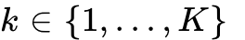 with a point-estimate mastery probability, WayfinderBeliefState maintains a factored probabilistic belief state 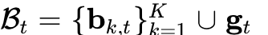 across seven state dimensions⁴:

State Dimension | Mathematical Representation | Update Signal & Dynamic Role in Wayfinder
1. Mastery Probability & Epistemic Uncertainty | Conjugate Beta distribution  with mean 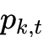 and variance 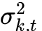⁴. | Updated via accuracy 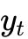, confidence , and latency weight 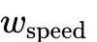. High variance triggers diagnostic probes; low variance enables practice or transfer⁴.
2. Misconception Probabilities | Bug probability vector 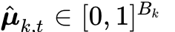 over cataloged procedural bugs⁴. | High-confidence errors (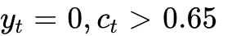) cause a sharp posterior jump (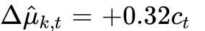); side-by-side contrast cases dismantle active bugs (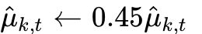)⁴.
3. Context Transfer Strength | Latent transfer capability 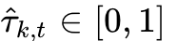 coupled via domain transfer matrix 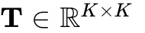⁴. | Standard drill barely moves transfer (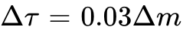), whereas far-transfer probes boost 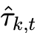 and propagate gains to coupled downstream skills⁴.
4. Memory Stability & Decay Lag | Half-life stability 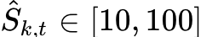 and elapsed time since practice 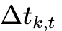⁴. | Temporal decay discounts 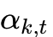 via , lowering and inflating variance . Spaced retrieval multiplies 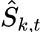⁴.
5. Patch Marginal Learning Rate | Exponentially weighted moving average 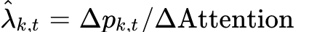⁴. | Decays exponentially with consecutive homogeneous drill on the same skill (), driving MVT patch-leaving and role-switching decisions¹.
6. Metacognitive Calibration | Rolling Brier score 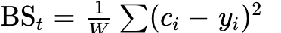 and signed bias 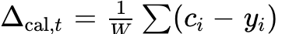⁴. | Quantifies overconfidence (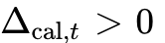) vs. underconfidence (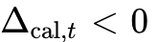), governing contrast-case selection and Meta-loop reflection⁴.
7. Strategy & Context Profile | Global vector 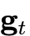: help-seeking profile, frustration 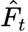, time budget, and learner mode⁴. | Tracks hint abuse vs. help avoidance (Help Tutor rules)⁷ and enforces hard vetoes when frustration spikes or the learner selects a policy mode⁴.
Modeling mastery via the conjugate Beta distribution provides closed-form expressions for both posterior mean mastery and epistemic variance ⁴:
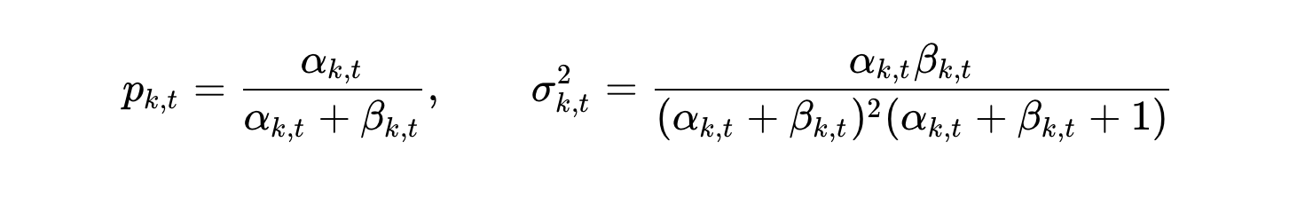
When a skill goes unpracticed over an interval 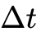, discounting the concentration parameters 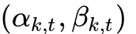 toward the prior simultaneously pulls back mean mastery and inflates epistemic uncertainty ⁴. This captures a critical distinction that scalar BKT misses: a newly encountered skill at 70% mastery () and a heavily practiced skill at 70% mastery () require completely different pedagogical actions⁴.

3.2 The Objective Function: Expected Transferable Learning per Unit of Attention
At decision step , Wayfinder evaluates any candidate action 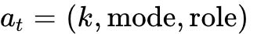 by scoring its Expected Transferable Learning per Unit of Attention (ETL/UA)⁴:
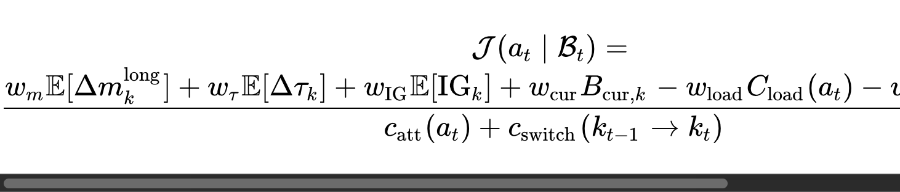
In this formulation, the numerator balances four positive value drivers against two cognitive cost/risk penalties, while the denominator normalizes by total attention expenditure⁴. Specifically, 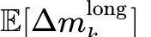 forecasts durable mastery gain retained after temporal decay (combining acquisition with stability reinforcement 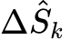)⁴; 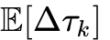 captures direct context-transfer growth plus downstream spillover across the transfer coupling matrix ⁴; 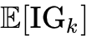 rewards posterior variance and misconception uncertainty reduction⁴; and 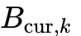 provides an option-value and curiosity bonus for skills that unlock major subtrees in the curriculum graph⁴. Against these gains, 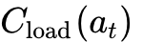 penalizes intrinsic and extraneous cognitive load (ranging from 0.15 for guided worked examples to 0.40–0.65 for un-scaffolded transfer probes)⁴, and 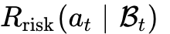 penalizes actions that risk frustration or overconfident error entrenchment when 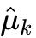 or is high⁴. Dividing by enforces Charnov's Marginal Value Theorem: switching to a new skill patch is only justified when its net instructional yield outweighs the cognitive travel cost ¹.
To plan beyond a single item, the 3-step receding-horizon MPC controller (choose_action_wayfinder_mpc) performs a beam search over horizon with discount factor 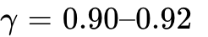, selecting the initial action that maximizes the cumulative trajectory score⁴:
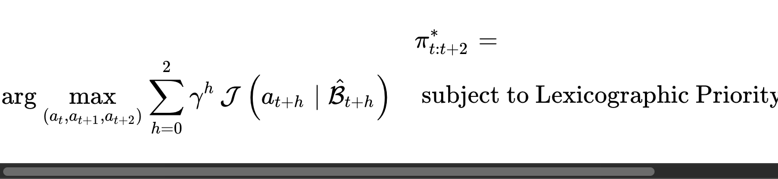

4. Multi-Scale Coordination, Foraging Policy, and Productive Surprise

4.1 The Four-Timescale Coordinator
Conventional adaptive systems collapse micro-step hints, skill switching, curriculum routing, and metacognitive reflection into one flat rule set, causing high-frequency oscillation. Wayfinder separates adaptation into four hierarchical timescales, where slower scales set reference priors and boundary constraints for faster scales:

Adaptation Scale | Operational Timescale | Primary State Variables Monitored | Control Decisions & Pedagogical Actions | Conflict Resolution Role
Micro | Seconds to minutes | Step accuracy , confidence , response latency 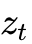, hint requests, productive-surprise quadrant⁴. | Graduated hint delivery, immediate error feedback, switching visual/symbolic representation, selecting next item or contrast case⁷. | Executes within the skill patch and role selected by the Meso loop; triggers an emergency Meso abort if frustration spikes.
Meso | Minutes to hours | Patch marginal learning rate 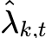, epistemic variance , bug probability 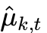, switching cost ⁴. | Stay or leave a skill patch (MVT foraging), shift apprenticeship role (Observer 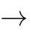 Practitioner Reviewer), review vs. explore⁴. | Constrains Micro item selection; arbitrates between local practice persistence and patch departure.
Macro | Days to weeks | KST inner/outer fringes, prerequisite readiness 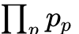, memory stability , option value , transfer ⁴. | Long-term path routing, prerequisite challenge tests, multi-skill synthesis projects, regenerative spaced-review scheduling⁵. | Sets the active candidate set of skills and due-review constraints for the Meso controller.
Meta | Weeks to months | Rolling Brier calibration , signed bias 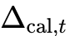, help-seeking error rate, learner mode overrides⁴. | Double-loop adaptation: calibrating confidence vs. accuracy, teaching help-seeking & review habits, negotiating learning goals²⁷. | Governs global objective weights and honors learner-selected mode vetoes (Explore, Consolidate, Challenge, Recover).

4.2 How Cognitive Foraging Changes the Policy
Treating each skill as an ecological patch with marginal learning rate provides a principled mathematical answer to five scheduling problems that current systems handle with ad hoc heuristics¹:
First, when to stop practising a skill (patch departure) is governed by Charnov's tangent condition rather than an arbitrary mastery ceiling¹. As consecutive practice steps accumulate in patch , local resource depletion flattens the gain slope ⁴. Wayfinder leaves patch as soon as falls below the switch-cost-adjusted return of the best alternative patch , preventing wheel-spinning⁴. Second, when to switch representation or cognitive role within a patch is determined by comparing method-specific marginal rates: if overall mastery 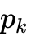 is still low (e.g., 0.218) and standard practice has flattened () due to an active misconception (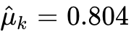), the Meso controller stays on the essential prerequisite patch but shifts the instructional mode to a contrasting case followed by a guided worked example, rejuvenating the learning rate⁴.
Third, when to review (patch regeneration) emerges naturally from the same foraging equation without a competing cron scheduler⁴. In queueing-network models of spaced repetition, Reddy et al. (2016) demonstrated a sharp phase transition: if new-item arrival rates exceed a critical threshold relative to review capacity, review queues become unstable and blow up⁵. Wayfinder avoids queue instability by modeling elapsed time 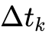 on previously mastered skills (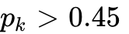) as ecological patch regeneration: as a skill rests and experiences slight concentration decay, the stability multiplier available from a brief spaced_review (attention cost 0.80) grows until its expected long-term mastery return organically surpasses the diminishing return of the current patch⁴. Fourth, when to skip ahead and when to explore a new topic are governed jointly by Bayesian experimental design and option value: if a learner responds rapidly and accurately with high confidence to a diagnostic probe on a high-option-value outer-fringe skill, posterior variance collapses and unlocks downstream paths immediately⁴.

4.3 Productive Surprise Instead of Scalar Difficulty
In psychometric speed-accuracy response models (Maris & van der Maas, 2012), response time and accuracy 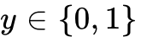 jointly form a sufficient statistic for latent ability under the Signed Residual Time (SRT) scoring rule, where fast accurate responses earn maximum credit and response latency measures the distance between learner ability and item difficulty⁶. Simultaneously, cognitive psychology research by Butterfield and Metcalfe (2001, 2006) and Metcalfe and Finn (2011) establishes the hypercorrection effect: when learners commit an error with high confidence, corrective feedback triggers a metacognitive surprise spike and attentional orienting response that makes the correction substantially more likely to be encoded than feedback on low-confidence errors¹⁵.
Wayfinder combines these mechanisms into a four-quadrant Productive Surprise Diagnostic Matrix driven by accuracy (), confidence (), and normalized response latency ()⁴:

Confidence Level | Response Accuracy | Latency Signature (ztz_tzt​) | Cognitive Diagnosis & Criticality Regime | Prescribed Wayfinder Action & Role Shift | Transparent Learner Explanation
High Confidence (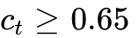) | High Accuracy (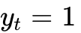) | Fast (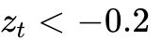) | Too Predictable (Habituation Risk): Prediction error is near zero; current representation is fluent⁴. | Independent / Reviewer Role: Strip scaffolding (fade help), increase task ambiguity, or serve a transfer_probe in a novel context⁴. | "You solved this quickly with high confidence, so I am removing hints and shifting to an unfamiliar context to test transfer."
Low Confidence (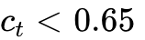) | Low Accuracy (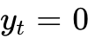) | Slow (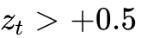) | Too Chaotic (Cognitive Overload / Wheel-Spinning): Task exceeds current schema or prerequisite readiness¹⁴. | Observer / Guided Role: Serve a worked_example_guided, a contrast_case, or retreat to an inner-fringe prerequisite⁴. | "This step is creating high cognitive load. Let's step back to a guided worked example with visible expert decisions."
High Confidence () | Low Accuracy () | Fast / Mod (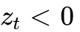) | Misconception or Calibration Failure (Hypercorrection Window): Fluent execution of a buggy rule¹⁵. | Observer Guided Role: Trigger a side-by-side contrast_case with an explicit prediction prompt, followed by guided practice⁴. | "I am switching to a contrast case because your confidence is high while accuracy is low, indicating a specific rule trap."
Low Confidence () | High Accuracy () | Slow / Mod (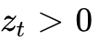) | Fragile / Unconsolidated Mastery: Correct outcome reached tentatively or via slow trial-and-error⁴. | Practitioner / Articulation Role: Prompt for self-explanation/articulation or serve a near-transfer consolidation probe¹⁶. | "Your answer was right, but your confidence was low. Let's consolidate why that strategy worked before moving on."
As Schwartz and Bransford (1998) demonstrated in "A Time for Telling," asking learners to analyze contrasting cases sensitizes them to critical differentiating features that novices otherwise overlook; once they notice those distinctions, they are prepared to learn deeply from an explicit explanation or guided worked example, outperforming direct instruction alone on 1-week delayed transfer tests⁵⁴. Pairing the hypercorrection effect¹⁵ with contrasting cases⁵⁴ allows Wayfinder to convert high-confidence mistakes into the engine's highest-yield learning moments.

5. The Meta Loop: Double-Loop Adaptation and Open Learner Agency
In organizational and cognitive systems theory, Argyris and Schön (1978) distinguish between single-loop learning—which acts like a thermostat, adjusting action strategies to keep performance within fixed governing variables—and double-loop learning, which feeds errors and consequences back to question and modify the governing variables, assumptions, and norms themselves⁶². Conventional adaptive courseware is strictly single-loop: it silently adjusts item difficulty while keeping the learner passive, frequently inducing "Model I" defensive routines such as hint abuse, gaming the system to protect streaks, or avoidance of challenge⁷.
Wayfinder implements double-loop adaptation: the outer loop adapts the instructional path, while the inner (meta) loop improves the learner's self-model, metacognitive calibration, and self-regulatory agency²⁷.

5.1 Operationalizing the SMILI☺ Open Learner Model and Help Tutor
Building on Bull and Kay's (2007, 2016) SMILI☺ (Student Models that Invite the Learner In) Open Learner Modelling (OLM) framework³² and Aleven, McLaren, Roll, and Koedinger's (2006) Help Tutor⁷, the Wayfinder Meta Loop integrates five concrete mechanisms into the learner interface. First, before attempting diagnostic or transfer tasks, the learner commits to a rapid confidence prediction ("Commit before you check")⁵¹, and the inspectable OLM displays their rolling calibration trajectory (predicted confidence vs. realized accuracy and epistemic uncertainty ) rather than gamified point totals⁴. Second, following the Help Tutor cognitive model⁷, the Meta Loop monitors step-level help-seeking errors—specifically trying unfamiliar steps without consulting hints/glossary (help avoidance) and clicking through hints rapidly without deliberation (help abuse)—and delivers explicit metacognitive coaching on how to use scaffolding deliberately⁷.
Third, in alignment with Argyris and Schön's "Model II" governing values (valid information, free and informed choice, and internal commitment)⁶³, the learner can select or negotiate their active policy mode at any time: Explore (boosting outer-fringe discovery and curiosity weight 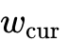), Consolidate (prioritizing stability 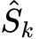 and variance reduction), Challenge (prioritizing far-transfer probes 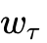 with faded scaffolds), or Recover (lowering cognitive load cost 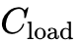 via worked examples and familiar review)⁴. Fourth, when a learner overrides a recommended activity, Wayfinder treats the override as Bayesian preference and context evidence updating (such as inferring acute fatigue or a preference for conceptual overview before drill) rather than penalizing the learner³². Fifth, every controller transition is accompanied by a transparent causal explanation derived directly from the active terms of the ETL/UA objective function⁴.

6. Conflict Resolution Protocol & The Git Merge Conflict Execution Trace

6.1 Resolving Signal Conflicts Without Independent Heuristics
When multiple pedagogical signals disagree—for example, skill mastery suggests advancing, calibration indicates confident-wrong misconceptions, and a spaced review is due—a heuristic engine suffers from rule-priority collisions. Wayfinder resolves all conflicts inside its single controller by combining lexicographic hard constraints with expected long-term ETL/UA optimization⁴:
- Priority 1 — Consent, Learner Mode, and Affective Safety (Hard Veto): The learner's chosen policy mode (Recover, Explore, etc.) and the frustration/confusion ceiling (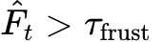) hold absolute veto power over high-load un-scaffolded actions⁴. Generative AI models have zero authority to override these safety constraints.
- Priority 2 — Due Review Floor (Queue Stability Constraint): To prevent the forgetting phase transition identified by Reddy et al. (2016)⁵, any skill whose elapsed lag exceeds its stability threshold (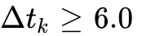 steps with and 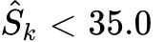) receives a priority constraint boost in the objective scorer so due reviews cannot be ignored indefinitely⁴.
- Priority 3 — Prerequisite Readiness Gate: In accordance with KST surmise relations⁹, outer-fringe skills whose joint prerequisite mastery 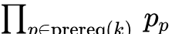 falls below 0.40 are gated from un-scaffolded practice unless the learner passes a diagnostic challenge probe⁴.
- Priorities 4 to 6 — Productive Struggle, Exploration, and Engagement (Continuous Objective Trade-off): Within the feasible action set satisfying Priorities 1–3, competing signals for productive struggle (misconception remediation and transfer), exploration (epistemic information gain), and engagement are resolved quantitatively by comparing their discounted 3-step contribution to 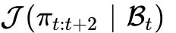⁴.

6.2 Concrete Execution Trace: The Git Merge Conflict Scenario
To see how Wayfinder executes this protocol mathematically, consider the exact trace from our simulation environment (KnowledgeLandscape over 6 Git skills: 0: Git Commit & Branch Basics, 1: Git Merge & Fast-Forward, 2: Git Merge Conflicts, 3: Git Rebase & Linear History, 4: Interactive Rebase & Squash, 5: Distributed Team PR Workflows)⁴.
Suppose a learner has mastered prerequisites 0 () and 1 () and is currently foraging in Patch 2 (2: Git Merge Conflicts)⁴. The learner attempts two consecutive standard merge conflict problems and misses both (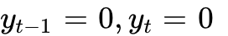) while reporting high confidence (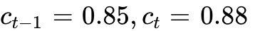) with fast response latency (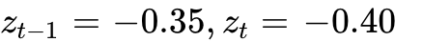) and rising hint use⁴.
At decision epoch , WayfinderBeliefState updates Skill 2 to a posterior mastery mean of 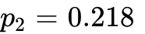 with epistemic variance 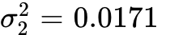⁴. Because both errors occurred rapidly at high confidence (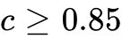), the posterior misconception probability jumps to 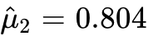 (diagnosing a classic procedural bug, such as deleting conflict markers or blindly accepting HEAD without integrating both branch changes), signed overconfidence bias reaches 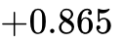, and the patch marginal learning rate on standard practice flattens to 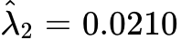⁴. Comparing the rejected heuristic action (standard_practice on Skill 2) against Wayfinder's selected intervention (contrast_case on Skill 2) illustrates how the controller shifts the kind of thinking required⁴:

Objective Component / Metric | Symbol & Weight | Candidate A: Serve Another standard_practice (Rejected) | Candidate B: Serve contrast_case + Prediction (Selected) | Pedagogical & Mathematical Rationale
Expected Long-Term Mastery Gain | 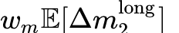 | +0.0099 | +0.3726 | Standard practice is throttled by patch depletion () and bug interference (). Contrast case triggers hypercorrection⁴.
Expected Transfer Gain | 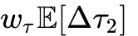 | +0.0576 | +0.0936 | Differentiating contrasting merge histories builds a transferable mental model for downstream Rebasing and PR workflows⁴.
Expected Information Gain | 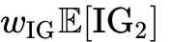 | +0.0225 | +0.3262 | A targeted contrast probe discriminates the exact misconception (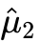) far more efficiently than another failed drill item⁴.
Option Value & Curiosity Bonus | 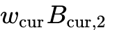 | +0.0606 | +0.0606 | Skill 2 has high curriculum option value (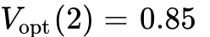) because it gates Skills 4 and 5⁴.
Cognitive Load Cost | 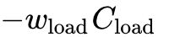 | -0.1050 | -0.1225 | Side-by-side comparison requires slightly higher cognitive effort than rote drill, which is justified by its hypercorrection yield⁴.
Frustration & Overconfidence Risk | 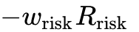 | -0.5996 | 0.0000 | Serving another un-scaffolded conflict when carries a severe risk of wheel-spinning and entrenched error⁴.
Attention + Switching Cost | 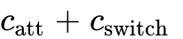 | 1.00 units | 1.15 units | Staying in Skill 2 incurs zero skill-switch cost (), while the contrast case requires 1.15 attention units⁴.
Immediate Step ETL/UA Score | 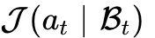 | -0.5540 | +0.6351 | contrast_case outperforms standard_practice by +1.1891 ETL/UA points at step ⁴.
3-Step MPC Trajectory Score | 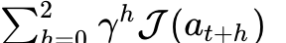 | Pruned (< -0.50) | +1.3314 | MPC plans the synergistic 3-step sequence: contrast_case worked_example_guided transfer_probe, plus spaced review⁴.
Rather than merely serving an "easier" merge conflict, the 3-step MPC planner (Wayfinder_MPC_3Step) constructs a four-stage pedagogical trajectory across timescales⁴. In Step 1 (Immediate Micro/Meso Action — contrast_case, Observer Role, Step Score +0.6351), the controller presents a side-by-side contrast case (e.g., comparing a fast-forward merge against a true three-way conflicting commit graph) and asks the learner to predict which branch lines must be retained, accompanied by the explanation: "I am switching to a contrast case because your confidence is high while accuracy is low, and the learning rate on this skill has flattened"⁴. In Step 2 (Lookahead — worked_example_guided, Guided Practitioner Role), having created a "time for telling" by dismantling the misconception ( drops from 0.804 to 0.442)⁴, the planner schedules a guided merge with visible expert decision rationales, capturing a 1.45x–1.55x instructional synergy boost⁴. In Step 3 (Lookahead 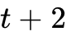 — transfer_probe, Independent Practitioner Role, Cumulative 3-Step MPC Score +1.3314), scaffolding fades and the learner resolves an independent merge conflict in a novel repository context (1.40x–1.48x fading synergy)⁴. Finally, in Step 4 (Macro Horizon +3 Days — spaced_review, Patch Regeneration), the controller schedules a spaced retrieval probe three days later to multiply memory stability 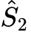 and block the prior high-confidence misconception from resurfacing⁴.

7. Quantitative Simulation Benchmark Across Learner Archetypes
Before piloting an adaptive controller with live students, learning engineering methodology (Clement, Roy, Oudeyer, & Lopes, 2015; Rafferty et al., 2016) requires stress-testing candidate policies across diverse simulated learner populations³. We evaluated four controllers across 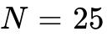 Monte Carlo episodes of 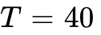 instructional steps each, followed by a 14-day unpracticed retention decay period (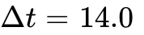), over the 6-skill Git curriculum landscape⁴.

7.1 Synthetic Learner Archetypes and Controller Conditions
The simulation benchmark tests five synthetic learner archetypes designed to expose specific failure modes of traditional adaptive engines⁴. The Calibrated Learner represents a baseline profile with normal forgetting (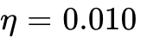), low initial misconceptions (), and well-calibrated confidence (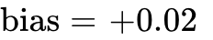)⁴. The Misconception-Prone Overconfident Learner starts with high active bug strengths (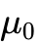 up to 0.68 on Merge Conflicts) and strong overconfidence (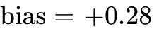), stalling on standard drill but responding strongly to hypercorrection when given contrasting cases⁴. The Wheel-Spinner exhibits severe diminishing returns on un-scaffolded standard practice () whenever prerequisite fluency is incomplete or cognitive load is high⁴. The Underconfident Hint-Abuser possesses solid learning potential but strong underconfidence (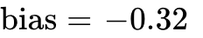), over-relying on hints unless guided through consolidated self-explanation and transfer⁴. Finally, the Rapid Forgetter / Context-Bound Learner acquires rote performance quickly but suffers rapid memory decay (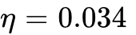, or 3.4x baseline decay) unless stabilized via well-timed regenerative spaced reviews and context transfer probes⁴.
Against these five archetypes, we compared four controllers: (1) BKT_Threshold_SM2, a classical BKT mastery controller (practicing the lowest unmastered skill until 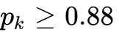) interrupted every 8 steps by a rigid SuperMemo-2 / Leitner review rule⁴; (2) IRT_85_Rule, a scalar difficulty-dial controller that continuously selects the skill and standard practice item closest to the 85% target accuracy band⁴; (3) Wayfinder_Greedy_1Step, which uses the full distributional WayfinderBeliefState, MVT foraging rule, and Productive Surprise objective myopically (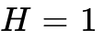)⁴; and (4) Wayfinder_MPC_3Step, the full Wayfinder controller with 3-step receding-horizon MPC lookahead (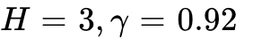)⁴.
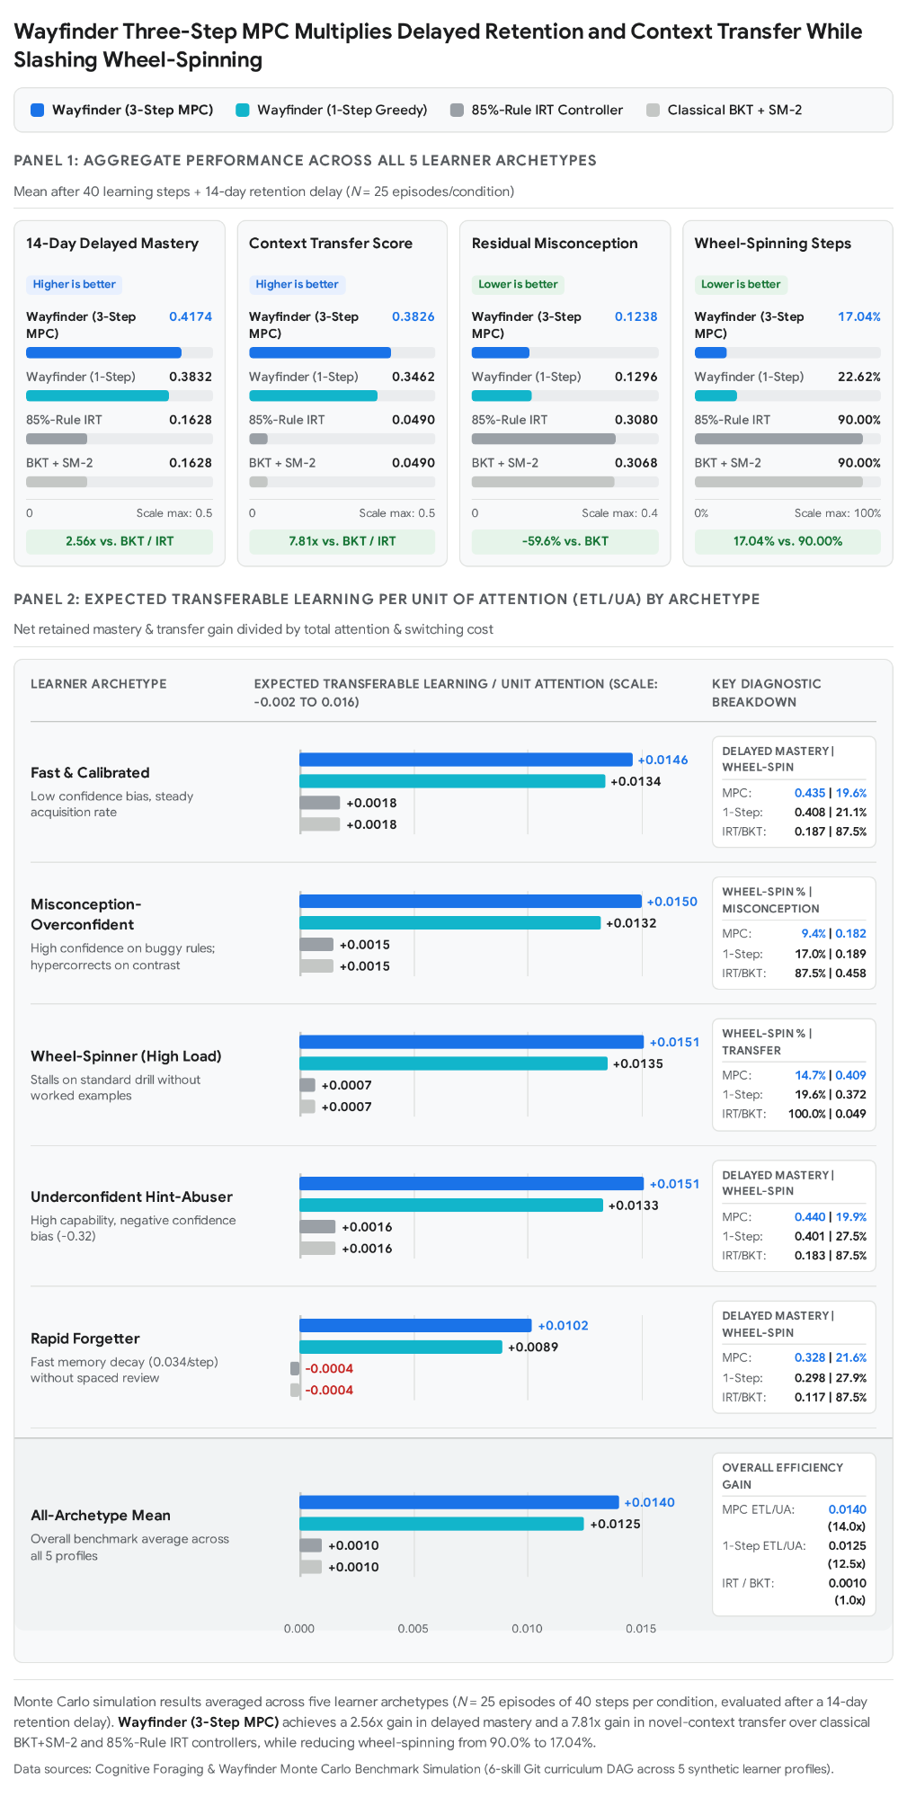

7.2 Complete Monte Carlo Benchmark Results and Analysis
The table below reports the full breakdown across all five learner archetypes and the cross-population summary averages from the simulation benchmark⁴:
Learner Archetype | Controller Policy | 14-Day Delayed Mastery | Context Transfer Score | Residual Misconception (μ^​) | Calibration Brier Score | Wheel-Spinning Steps (%) | ETL per Unit of Attention
Calibrated | BKT_Threshold_SM2 | 0.187 | 0.053 | 0.195 | 0.267 | 87.5% | 0.0018
Calibrated | IRT_85_Rule | 0.187 | 0.053 | 0.195 | 0.278 | 87.5% | 0.0018
Calibrated | Wayfinder_Greedy_1Step | 0.408 | 0.365 | 0.079 | 0.212 | 21.1% | 0.0134
Calibrated | Wayfinder_MPC_3Step | 0.435 | 0.394 | 0.075 | 0.228 | 19.6% | 0.0146
Misconception-Overconfident | BKT_Threshold_SM2 | 0.178 | 0.052 | 0.458 | 0.428 | 87.5% | 0.0015
Misconception-Overconfident | IRT_85_Rule | 0.178 | 0.052 | 0.460 | 0.451 | 87.5% | 0.0015
Misconception-Overconfident | Wayfinder_Greedy_1Step | 0.406 | 0.357 | 0.189 | 0.221 | 17.0% | 0.0132
Misconception-Overconfident | Wayfinder_MPC_3Step | 0.446 | 0.406 | 0.182 | 0.224 | 9.4% | 0.0150
Wheel-Spinner | BKT_Threshold_SM2 | 0.149 | 0.049 | 0.421 | 0.402 | 100.0% | 0.0007
Wheel-Spinner | IRT_85_Rule | 0.149 | 0.049 | 0.418 | 0.396 | 100.0% | 0.0007
Wheel-Spinner | Wayfinder_Greedy_1Step | 0.403 | 0.372 | 0.179 | 0.229 | 19.6% | 0.0135
Wheel-Spinner | Wayfinder_MPC_3Step | 0.438 | 0.409 | 0.172 | 0.231 | 14.7% | 0.0151
Underconfident Hint-Abuser | BKT_Threshold_SM2 | 0.183 | 0.053 | 0.199 | 0.282 | 87.5% | 0.0016
Underconfident Hint-Abuser | IRT_85_Rule | 0.183 | 0.053 | 0.205 | 0.267 | 87.5% | 0.0016
Underconfident Hint-Abuser | Wayfinder_Greedy_1Step | 0.401 | 0.365 | 0.090 | 0.213 | 27.5% | 0.0133
Underconfident Hint-Abuser | Wayfinder_MPC_3Step | 0.440 | 0.401 | 0.085 | 0.237 | 19.9% | 0.0151
Rapid Forgetter | BKT_Threshold_SM2 | 0.117 | 0.038 | 0.261 | 0.398 | 87.5% | -0.0004
Rapid Forgetter | IRT_85_Rule | 0.117 | 0.038 | 0.262 | 0.409 | 87.5% | -0.0004
Rapid Forgetter | Wayfinder_Greedy_1Step | 0.298 | 0.272 | 0.111 | 0.220 | 27.9% | 0.0089
Rapid Forgetter | Wayfinder_MPC_3Step | 0.328 | 0.303 | 0.105 | 0.236 | 21.6% | 0.0102
ALL ARCHETYPES (MEAN) | BKT_Threshold_SM2 | 0.1628 | 0.0490 | 0.3068 | 0.3554 | 90.00% | 0.0010
ALL ARCHETYPES (MEAN) | IRT_85_Rule | 0.1628 | 0.0490 | 0.3080 | 0.3602 | 90.00% | 0.0010
ALL ARCHETYPES (MEAN) | Wayfinder_Greedy_1Step | 0.3832 | 0.3462 | 0.1296 | 0.2190 | 22.62% | 0.0125
ALL ARCHETYPES (MEAN) | Wayfinder_MPC_3Step | 0.4174 | 0.3826 | 0.1238 | 0.2312 | 17.04% | 0.0140
Three core findings stand out from the simulation data. First, classical BKT_Threshold_SM2 and IRT_85_Rule controllers spend 100.0% of their steps wheel-spinning on the wheel_spinner archetype and yield negative net transferable learning (-0.0004 ETL/UA) on the rapid_forgetter archetype after a 14-day delay⁴. Because they only serve standard_practice items and lack a foraging rule or representation-switching mechanism, they trap the learner on early skills where local patch depletion () and active misconceptions () throttle learning gains below the forgetting rate⁴.
Second, combining the hypercorrection window with contrasting cases eradicates persistent bugs. On the misconception_overconfident archetype, baseline controllers leave residual misconceptions at 0.458–0.460 because standard practice errors do not dismantle the underlying buggy rule⁴. Wayfinder detects the high-confidence error signature (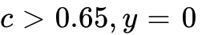), deploys contrast_case interventions during the hypercorrection window¹⁵, and reduces residual misconceptions by 60.3% (down to 0.182) while cutting wheel-spinning to 9.4% of steps⁴.
Third, 3-step MPC lookahead provides a substantial performance gain over 1-step greedy foraging. While Wayfinder_Greedy_1Step captures the initial leap over classical baselines by introducing variance-aware beliefs, MVT foraging, and multimodal action types, Wayfinder_MPC_3Step achieves a further +8.9% relative increase in 14-day delayed mastery (0.4174 vs. 0.3832), a +10.5% relative increase in context transfer (0.3826 vs. 0.3462), a 24.7% relative reduction in wheel-spinning (17.04% vs. 22.62%), and a +12.0% boost in overall ETL per unit of attention (0.0140 vs. 0.0125)⁴. Lookahead planning prevents the greedy controller from oscillating between patches or missing the multi-step "time for telling" sequence (contrast_case worked_example_guided transfer_probe)⁴. Notice also a subtle empirical trade-off: Wayfinder_MPC_3Step exhibits a slightly higher rolling Brier score (0.2312 vs. 0.2190 for Greedy) because the 3-step planner deliberately pushes learners into more ambitious transfer_probe challenges across newly unlocked outer-fringe skills, temporarily inducing productive prediction errors as learners stretch into novel contexts⁴.

8. Engineering Implementation Roadmap: What to Build First (Wayfinder v1) & Guardrails
A frequent mistake in modern edtech engineering is attempting to cure heuristic drift by training an end-to-end Deep Reinforcement Learning (DRL) agent or Deep Knowledge Tracing (DKT) network on noisy historical logs—an approach that requires massive sample sizes, lacks parameter plausibility, and cannot explain its pedagogical trade-offs to learners or authors²⁵. Conversely, handing curriculum routing directly to a conversational LLM invites sycophancy—where the AI prematurely gives away answers to keep the user satisfied—and destroys prerequisite accountability.

8.1 Seven-Stage Phased Implementation Plan for Wayfinder v1
The first production version of Wayfinder does not need a neural network; it can be built as a deterministic, approximate, and fully explainable controller across seven sequential stages⁴:
- Keep BKT-Lite, but Add a Variance Estimate (Beta-BKT + Misconception Graph): Replace single mastery scalars in the learner state store with conjugate 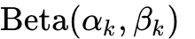 parameter pairs (giving exact mean and epistemic variance ), an active misconception probability vector mapped to authored distractor/bug tags¹⁷, and a temporal concentration decay function driven by elapsed time and stability ⁴.
- Add a Three-Step Lookahead Scorer Using the ETL/UA Objective: Implement score_action_wayfinder and choose_action_wayfinder_mpc using a deterministic expected-belief transition model over horizon ⁴. Scoring 6 skills across 6 action modes evaluates 36 candidates at step 1, expands the top 5–6 beam branches at step 2, and scores the top 4 branches at step 3, requiring no neural network inference⁴.
- Add a Marginal Value Foraging Rule for Leaving a Skill: Track the exponentially weighted moving average of patch marginal learning rate and define the domain switching-cost matrix 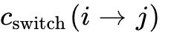 over the curriculum DAG¹. Fold spaced review directly into the same scorer as patch regeneration rather than running a competing review scheduler⁴.
- Add a Productive-Surprise Band Using Confidence, Accuracy, and Latency: Instrument the UI to capture a fast pre-submission confidence prediction alongside item-level normalized response latency and hint-opening timestamps⁴. Route the joint 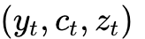 signal through the four-quadrant Productive Surprise matrix (Section 4.3) to trigger contrast cases, guided worked examples, consolidation prompts, or scaffold fading⁴.
- Add a Double-Loop Calibration and Agency Interface: Expose the SMILI☺-compliant calibration graph (predicted confidence vs. actual performance over time) and the four learner policy modes (Explore, Consolidate, Challenge, Recover) in the student dashboard, logging learner overrides as Bayesian preference evidence rather than disobedience⁴.
- Add Transfer Probes and Contrast Cases to the Content Schema: Expand authoring templates so each skill patch includes at least one side-by-side contrast case targeting its primary misconception ⁵⁴, one guided worked example with visible expert decision steps²⁴, and one far-transfer probe set in a novel context⁴. Confine LLMs strictly to drafting candidate contrast cases, worked examples, and Socratic hints under the deterministic controller's authority.
- Tune the Controller on Simulated Learners Before Live Piloting: Run offline Monte Carlo sweeps across the five synthetic learner archetypes (calibrated, misconception_overconfident, wheel_spinner, underconfident_hint_abuser, and rapid_forgetter) to calibrate objective weights and verify zero policy oscillation prior to classroom deployment⁴.

8.2 Architectural Guardrails: What Not to Do
To preserve the mathematical integrity and pedagogical accountability of the engine over its lifecycle, engineering and product teams should enforce six strict guardrails:

Prohibited Anti-Pattern | Failure Mechanism in Production | Wayfinder Architectural Guardrail
1. Do Not Add More Independent Heuristics | Patching edge cases with standalone if/else triggers creates hidden priority collisions and policy drift. | All new signals must enter as state variables in 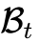, cost/value terms in 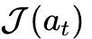, or explicit lexicographic constraints in the single MPC controller⁴.
2. Do Not Let AI Choose the Path | Conversational LLMs optimize for immediate user satisfaction and conversational coherence, leading to premature answer-giving and skipped prerequisites. | AI cannot be the policy authority. Keep the Wayfinder controller deterministic and accountable; use LLMs strictly to generate content and hints within the chosen action mode.
3. Do Not Optimize Engagement Alone | Extrinsic gamification (streaks, leaderboards, XP counters) displaces intrinsic motivation, distorts feedback to self-level, and amplifies anxiety⁵³. | Treat engagement strictly as a survivability constraint (frustration veto) and a small curiosity/option-value bonus (), never the primary objective⁴.
4. Do Not Reduce Difficulty to One Scalar | A single difficulty parameter conflates intrinsic cognitive load, problem ambiguity, scaffolding depth, and context transfer distance²⁴. | Maintain separate coordinates for cognitive load (), apprenticeship role/help (Observer Guided Independent), ambiguity, and transfer distance ()⁴.
5. Do Not Assume the Skill Graph Is Fixed | Hard-coding a static prerequisite tree prevents learners and authors from bridging concepts organically or adding remediation patches²³. | Treat the KST surmise graph as extensible: allow authors and learners to attach new sub-patches, contrast cases, and transfer links dynamically²³.
6. Do Not Hide the Controller's Trade-Off | Silently switching topics or lowering item difficulty breeds learner distrust, confusion, and defensive "Model I" gaming⁶³. | The explanation is part of the system. Surface the exact belief mismatch (e.g., confidence vs. accuracy or patch depletion) in every transition banner⁴.

Works cited
- Time to fly: A comparison of marginal value theorem approximations, https://repository.lsu.edu/cgi/viewcontent.cgi?article=1701&context=agrnr_pubs
- Information Foraging Theory - Peter Pirolli, https://www.peterpirolli.com/ewExternalFiles/31354_C01_UNCORRECTED_PROOF.pdf
- Faster Teaching via POMDP Planning - Patrick Shafto, https://shaftolab.com/assets/papers/rafferty2015.pdf
- unknown_url
- Unbounded Human Learning: Optimal Scheduling for Spaced, https://kdd.org/kdd2016/papers/files/rpp0744-reddyAT3.pdf
- (PDF) Speed-Accuracy Response Models: Scoring Rules based on, https://www.researchgate.net/publication/268019650_Speed-Accuracy_Response_Models_Scoring_Rules_based_on_Response_Time_and_Accuracy
- Toward Meta-cognitive Tutoring: A Model of Help- Seeking with a, https://www.cs.cmu.edu/~bmclaren/pubs/AlevenEtAl-TowardMetaCognitiveTutoring-IJAIED2006.pdf
- Performance Factors Analysis – A New Alternative to Knowledge, https://pact.cs.cmu.edu/koedinger/pubs/AIED%202009%20final%20Pavlik%20Cen%20Keodinger%20corrected.pdf
- The Assessment of Knowledge in Theory and in Practice - ALEKS, https://www.aleks.com/about_aleks/Science_Behind_ALEKS.pdf
- (PDF) Knowledge Spaces and Learning Spaces - ResearchGate, https://www.researchgate.net/publication/284579542_Knowledge_Spaces_and_Learning_Spaces
- Enhancing human learning via spaced repetition optimization - PMC, https://pmc.ncbi.nlm.nih.gov/articles/PMC6410796/
- The Eighty Five Percent Rule for optimal learning - ResearchGate, https://www.researchgate.net/publication/337036886_The_Eighty_Five_Percent_Rule_for_optimal_learning
- (PDF) The Eighty Five Percent Rule for Optimal Learning, https://www.researchgate.net/publication/346858391_The_Eighty_Five_Percent_Rule_for_Optimal_Learning
- Persistence or Wheel-Spinning? Problem Solving During, https://educationaldatamining.org/edm2026/proceedings/2026.EDM.poster-demo-papers.417/index.html
- The Hypercorrection Effect - Structural Learning, https://www.structural-learning.com/post/hypercorrection-effect-teachers-guide
- Cognitive Apprenticeship: Methods and Evidence, https://en.cognitivepsychology.com/Cognitive_Apprenticeship
- Diagno$ing Bugs in a Simple Procedural Skill - Exquisitive, https://exquisitive.com/library/DiagnosingBugsSimpleProceduralSkill.pdf
- Foraging Under Uncertainty Follows the Marginal Value Theorem, https://pmc.ncbi.nlm.nih.gov/articles/PMC10996644/
- Quantifying the Adaptive Value of Learning in Foraging Behavior, https://users.soe.ucsc.edu/~msmangel/Eliassen%20et%20al%202009.pdf
- A Tutorial on Adaptive Design Optimization - Semantic Scholar, https://www.semanticscholar.org/paper/A-Tutorial-on-Adaptive-Design-Optimization-Myung-Cavagnaro/8f6fa6b60ddea3c8dedcce9244be4d8a19a64732
- (PDF) Adaptive Design Optimization: A Mutual Information-Based, https://www.researchgate.net/publication/40758728_Adaptive_Design_Optimization_A_Mutual_Information-Based_Approach_to_Model_Discrimination_in_Cognitive_Science
- Intrinsic Motivation Systems for Autonomous Mental Development, http://www.pyoudeyer.com/ims.pdf
- Intrinsic Motivation Systems for Autonomous Mental Development, https://scispace.com/papers/intrinsic-motivation-systems-for-autonomous-mental-a9mds7ef42
- Cognitive Apprenticeship Explained | PDF | Expert - Scribd, https://www.scribd.com/document/459268529/Collins
- On the interpretability of deep learning based models for knowledge, https://s2.smu.edu/~eclarson/pubs/2021_AAAI.pdf
- (PDF) Unbounded Human Learning: Optimal Scheduling for Spaced, https://www.researchgate.net/publication/310824802_Unbounded_Human_Learning_Optimal_Scheduling_for_Spaced_Repetition
- Toward Meta-cognitive Tutoring: A Model of Help Seeking with a, https://www.researchgate.net/publication/220049859_Toward_Meta-cognitive_Tutoring_A_Model_of_Help_Seeking_with_a_Cognitive_Tutor
- Performance Factors Analysis - A New Alternative to Knowledge, https://www.researchgate.net/publication/221297435_Performance_Factors_Analysis_-_A_New_Alternative_to_Knowledge_Tracing
- Joseph Beck | alphaXiv, https://www.alphaxiv.org/@joseph-beck
- Logistic Knowledge Tracing and Performance Factors Analysis, https://yilinl.quarto.pub/pfa/
- Why Deep Knowledge Tracing has less Depth than Anticipated - ERIC, https://files.eric.ed.gov/fulltext/ED599227.pdf
- SMILI: A Framework for Interfaces to Learning Data in Open Learner, https://www.researchgate.net/publication/290507185_SMILI_A_Framework_for_Interfaces_to_Learning_Data_in_Open_Learner_Models_Learning_Analytics_and_Related_Fields
- Diagnostic Models for Procedural Bugs in Basic Mathematical Skills*, https://exquisitive.com/library/DiagnosticModelsForProceduralBugs.pdf
- Susan Bull - alphaXiv, https://www.alphaxiv.org/@susan-bull
- GitHub - vanderbilt-data-science/knowledge-spaces: AI-powered, https://github.com/vanderbilt-data-science/knowledge-spaces
- Behavioral Science - Research Behind ALEKS, https://www.aleks.com/highered/behavior/research_behind_aleks
- Enhancing human learning via spaced repetition optimization - PNAS, https://www.pnas.org/doi/abs/10.1073/pnas.1815156116
- Multi-Armed Bandits for Intelligent Tutoring Systems - arXiv, https://arxiv.org/abs/1310.3174
- Multi-Armed Bandits for Intelligent Tutoring Systems, https://jedm.educationaldatamining.org/index.php/JEDM/article/view/JEDM111
- Cognitive Apprenticeship Model: Six Methods and Examples, https://www.coursebox.ai/blog/cognitive-apprenticeship-model-of-teaching-and-its-use-in-elearning
- Cognitive Apprenticeship: The Framework for Deeper Learning, https://www.timelygrader.ai/cognitive-apprenticeship
- Anna Rafferty - Publications, https://sites.google.com/site/annanrafferty/publications
- Optimal Scheduling for Spaced Repetition - Learning - ResearchGate, https://www.researchgate.net/publication/301844933_Unbounded_Human_Learning_Optimal_Scheduling_for_Spaced_Repetition
- Knowledge space - Wikipedia, https://en.wikipedia.org/wiki/Knowledge_space
- Learning Sequences - arXiv, https://arxiv.org/html/0803.4030v1
- Speed-Accuracy Response Models: Scoring Rules based on, https://www.cambridge.org/core/journals/psychometrika/article/abs/speedaccuracy-response-models-scoring-rules-based-on-response-time-and-accuracy/50D600FD53437CF8AEB9505998CF263D
- Algorithms for the adaptive assessment of procedural knowledge, https://pmc.ncbi.nlm.nih.gov/articles/PMC10616228/
- Comparing Knowledge Tracing and Performance Factor Analysis by, https://web.cs.wpi.edu/~nth/pubs_and_grants/ITS%202010/Gong%20Comparing%20Knowledge%20Tracing%20and%20Performance.pdf
- 85% Rule of Optimal Learning - Medium, https://medium.com/@drenizerama/85-rule-of-optimal-learning-15581eca9842
- The Eighty Five Percent “Rule” for Optimal Learning, https://aqrinternational.co.uk/the-eighty-five-percent-rule-for-optimal-learning-2
- The Hypercorrection Effect: Why Confident Mistakes Stick - LEAI, https://leai.app/blog/hypercorrection-effect-why-confident-mistakes-stick
- Errors committed with high confidence are hypercorrected - PubMed, https://pubmed.ncbi.nlm.nih.gov/11713883/
- The 85% Rule, Not Gamification: Adaptive Difficulty | IncluShift, https://inclushift.com/hub/briefs/eighty-five-percent-rule-not-gamification
- A Time for Telling - AAA Lab, https://aaalab.stanford.edu/papers/time_for_telling.pdf
- Charnov's marginal value theorem states that (a) the rate-maximizing, https://www.researchgate.net/figure/Charnovs-marginal-value-theorem-states-that-a-the-rate-maximizing-time-to-spend-in_fig5_229101074
- Article Summary: Schwartz & Bransford (1998) A Time for Telling, https://laurenmarg.com/2023/05/03/article-summary-schwartz-bransford-1998-a-time-for-telling-constructivism/
- Faster Teaching via POMDP Planning - PubMed, https://pubmed.ncbi.nlm.nih.gov/26400190/
- A Tutorial on Adaptive Design Optimization - PMC - NIH, https://pmc.ncbi.nlm.nih.gov/articles/PMC3755632/
- A Hierarchical Adaptive Approach to the Optimal Design of ... - AWS, https://mstrep.s3.amazonaws.com/publications/Kim_CogSci2014_Final.pdf
- Errors committed with high confidence are hypercorrected., https://www.semanticscholar.org/paper/Errors-committed-with-high-confidence-are-Butterfield-Metcalfe/cdbafcb94ae5bffc88b4aaf202cd7098a28c9473
- Cognitive Apprenticeship - DreamSpace Academy, https://dreamspace.academy/articles/definitions/cognitive-apprenticeship
- Argyris Single‑ and Double‑Loop Learning model, https://umbrex.com/resources/frameworks/organization-frameworks/argyris-single-and-double-loop-learning-model/
- chris argyris: theories of action, double-loop learning and, https://zeno-organisatieontwikkeling.nl/zeno/wp-content/uploads/2020/09/Argyris-C.-Theories-of-action-double-loop-learning-and-organizational-learning-revised-20-9-2011.pdf
- Learning Theories: Double-Loop Learning | TeachThought, https://www.teachthought.com/learning-posts/learning-theories-double-loop-learning/
- Open learner model - EduTech Wiki, https://edutechwiki.unige.ch/en/Open_learner_model
- Double Loop Learning in Organizations, https://theisrm.org/documents/Argyris%20(1977)%20Double%20Loop%20Learning%20in%20Organizations.pdf
- (PDF) Open Learner Models - ResearchGate, https://www.researchgate.net/publication/226516577_Open_Learner_Models
- Publications - Emma Brunskill, https://cs.stanford.edu/people/ebrun/publications.html

